Date Seen: _________________ Time Seen: ______________________
Contact Name: ______________ Phone Number: __________________

Location of Sighting: _________________________________________
(GPS, Trail #, distance from trailhead, nearest place name, etc)
Please CIRCLE what you saw: SCAT TRACKS 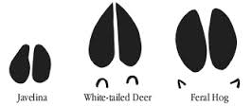OTHER____________________________________

Color of swine:_______________Size of swine: SMALL MEDIUM LARGE
Photos taken: YES NO Please provide, if taken

NUMBER OF SWINE SEEN: ____________________
Comments:

*Please return this form to the nearest US Forest Service Office or e-mail to: Brian.V.Archuleta@aphis.usda.gov.

